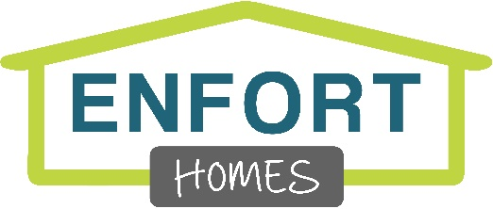
Residential Construction Labor
Enfort Homes – Kirkland, WA

We:
Love real estate and are passionate about building & developing the highest quality new construction homes in Kirkland, WA. We have a tight-knit culture and we work closely as a team, set high standards for all our construction projects and our chosen subs. We are fast paced and a growing company.

You:
Love problem-solving, satisfying clients & outsmarting the competition. You like it when no two days are the same and you have a direct impact on the company’s performance. You enjoy learning new skills & are a self-starter. You like working in teams but can be equally efficient working independently. You aren’t satisfied with just good results but are always trying to achieve more. You’re energetic & personable. You can have fun and be effective at the same time.

The job:
The Residential Construction Labor position plays an integral role with the development and maintenance of our new and existing proprieties. The ideal candidate will be able to perform physical tasks in a construction environment. The ability to lift, carry, climb ladders, and dig holes is necessary.
Additional skills, including Carpentry, Drywall, Painting, and the use of various power tools would be beneficial.
You will be required to have a reliable vehicle to transport yourself to different jobsites.

Each day, you might have any of these responsibilities:
- Job Site Clean-up
- Yard Maintenance
- Digging holes for utility access,
- Set signs, Mailboxes
- Safely Operate a variety of power & hand tools.
- Moving, securing, installing, building construction materials.
- Move items around a jobsite
- Move Items from jobsite to jobsite.
- Assist the superintendent to keep the schedule on track.

Optional Qualifications (Not required, but recommended):
- Basic Rough Carpentry work
- Basic Finish Carpentry work
- Installation of Trim Hardware.
- Drywall Patching.
- Concrete grinding, coring, and finishing.
- Perform warranty work and maintenance requests on sold houses.
- Attention to detail, including the ability to install things plumb, level, square and flush.

Qualifications:
- 2+ years of directly related construction experience.
- Reliable Truck or SUV capable of carrying supplies and driving jobsite to jobsite.
- Valid driver’s license
- Ability to lift and move up to 50lbs.
- Highly organized with strong attention to details and follow-through
- A positive attitude
- Ability to learn quickly
- Ability to follow directions.
- Self-motivated & proactive
- Proven ability to work with multiple projects and manage competing priorities.

Salary & Benefits:
- DOE;
- Bonuses based on personal performance.
- 3 weeks PTO + 8 Federal Holidays Off
- Company 4% Matching 401K re-invest program.
- Mileage reimbursed at IRS rate
- Cell Phone Allowance $50/mo
- Health & dental benefits

